Free Youtube views for an unlimited number of your videos! Boost your video's popularity using their simple and free method! Or, buy Youtube views and other services here.

[ythunder.com](https://ythunder.com/) has free & open registrations.

Have you ever faced this problem? You go to watch a video on [YouTube](https://ythunder.com/) like you would most nights, but all you’re getting is a black screen. Maybe at best you’re getting a [YouTube](https://ythunder.com/) black screen with sound but no image.

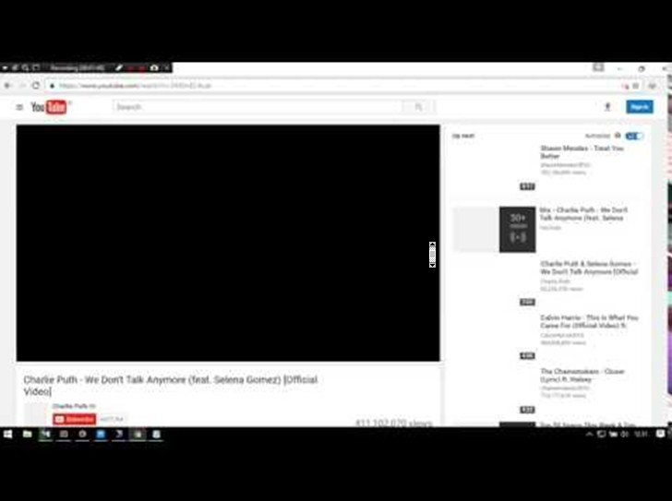Free Youtube views：[ythunder.com](https://ythunder.com/)

What’s going on?

You’ve been hit by the [YouTube](https://ythunder.com/) Black screen error – an issue that can affect users in a number of different ways for a variety of various reasons. Everything from a bad browser extension, to an ad blocker, or even a clunky video driver could be stopping you from catching up on your favorite funny cat content.

The good news is that we’re going to teach you what you can do when you see the dreaded black screen on [YouTube](https://ythunder.com/).

**Why Is My** [**YouTube**](https://ythunder.com/) **Screen Black?**

Before you can begin fixing the black screen [YouTube](https://ythunder.com/) video issue, you’re going to need to know what’s causing it. Sometimes, the problem will be with a bug on [YouTube](https://ythunder.com/)’s end – in that case, all you can do is wait for the problem to be fixed. However, if it’s something to do with your browser, your application, or even your ad-blocker, there are things that you can do.

Free Youtube views：[ythunder.com](https://ythunder.com/)

Here are just some of the things that can cause a [YouTube](https://ythunder.com/) screen black-out:

* Ad-blocking plugins: Sometimes, your ad-blocker will stop you from watching a video, rather than just filtering out the ads.
* Browser issues: An out-of-date or corrupted browser will stop you from doing various things. In this case, all you need to do is update your browser.
* Computer problems: If your computer isn’t working as it should be, you could face a black screen as a result. A simple restart can be enough to get things back to normal.
* Network errors: Slow internet speeds or local network issues prevent [YouTube](https://ythunder.com/) videos from loading correctly.

* [YouTube](https://ythunder.com/) app issues: If you’re wondering why you have a [YouTube](https://ythunder.com/) black screen on Android, the problem could be with an app on your phone.

**So, how do you fix these problems?**

One option is to log out of your Google account. If you’re suffering from an issue where your [YouTube](https://ythunder.com/) video plays, but a black screen covers the image, then it might help to log out of your Google account. It’s one of the easiest fix options. You can even avoid logging out entirely by simply opening an Incognito tab in Google Chrome and seeing whether the video runs smoothly in a private session.

If that doesn’t work, try:

**1. Adjusting Your AdBlocker Settings**

Search for “Adblock [YouTube](https://ythunder.com/) Black Screen” on Google, and you’ll find countless people complaining about the fact that their adblocker is stopping their content from playing. Ad blockers filter the content you’re shown online to make sure that you’re not constantly plagued by advertisements. However, sometimes they malfunction and block your videos by accident.

Try loading the page with your ad blocker temporarily turned off and see whether you still get the [YouTube](https://ythunder.com/) black screen. If you don’t, check your ad blocker to see if you can list [YouTube](https://ythunder.com/) videos as something your application doesn’t affect.

**2. Change Your Browser Settings**

If you’re suffering from a Chrome [YouTube](https://ythunder.com/) black screen, but the problem disappears on Firefox, then it may be something to do with your browser. Everything from corrupted cache data to cookies can stop videos from loading as they should. To rule out this problem, try reloading the page, clearing your cache, or simply switching to a different browser. Other options to try include:

* Logging out of your [YouTube](https://ythunder.com/) account
* Clearing the browser cache
* Searching for browser updates
* Restarting your computer
* Deleting browser cookies
* Disabling hardware acceleration on your web browser

**3. Deal with Network Problems**

If your [YouTube](https://ythunder.com/) video black screen isn’t fixed by restarting your computer or just clearing out your browser, then you might have an issue with your network connection. If your internet link is completely down, then you probably won’t be able to get onto [YouTube](https://ythunder.com/) at all. However, sometimes, when there’s only a small issue, you might see the black screen on [YouTube](https://ythunder.com/), and nothing else.

Usually, the best way to fix a connection issue that’s leading to [YouTube](https://ythunder.com/) playing a black screen is to power cycle your modem and router. If you’re connected to the internet via Wi-Fi, you can also consider switching to a wired connection. Other options include:

* Checking the speed of your internet connection with an online service
* Flushing your DNS cache
* Changing your DNS settings

**4. Update the Drivers on your Graphics Card**

Maybe the black screen on [YouTube](https://ythunder.com/) has nothing to do with your ad block, Chrome, or your network connection. Instead, it could be an issue with a bad GPU driver instead. If you see a [YouTube](https://ythunder.com/) black screen with audio, this is a good sign that there’s something wrong with the image, not your entire computer. To update your graphics drivers, go into your start menu and type DXDIAG into your menu. This will allow you to run the DirectX diagnostic tool.

Under the Device section in your diagnostic tool, you’ll be able to see the name of your graphics card. Use that to search for updates and drivers online.

**5. Restart Your** [**YouTube**](https://ythunder.com/) **App**

If the problem isn’t with your computer, but with a [YouTube](https://ythunder.com/) app black screen, then you might have an issue with the version of [YouTube](https://ythunder.com/) that’s on your phone. To deal with this issue, the easiest option is to clear out your cache and app data. However, if this doesn’t address the problem, then you might need to restart your device.

Another option may be to completely delete your [YouTube](https://ythunder.com/) app and reinstall it. You can also find out if the app is to blame by navigating to the mobile web version of [YouTube](https://ythunder.com/) on your smartphone and trying to view a video from there.

Hopefully, these tips have helped to fix the black screen on [YouTube](https://ythunder.com/) for you. If you have any other advice, feel free to share it in the comments below.Free Youtube views for an unlimited number of your videos! Boost your video's popularity using their simple and free method! Or, buy Youtube views and other services here.

[ythunder.com](https://ythunder.com/) has free & open registrations.